U.S. History
Chapter 6
Immigration Assignment
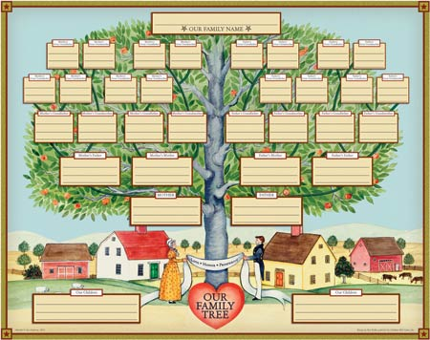
- Create a family tree.
  - Talk to family members- go back as far as you can
  - Color or possibly make a key
- Interview a family member (try to make it a grandparent or great aunt or uncle)
  - Ask them AT LEAST 10 questions about your family
  - 5 questions have been provided to get you started
    - Who is your earliest known ancestor?
      - Name:
      - Birth date:
      - Where did they live:
      - What was their job:
    - Do you have any unique/famous people in your family?
    - What areas in the United States has your family lived?
    - What are some unique foods that your family is known for eating?
    - What were your chores and what did you do for fun?

Grading/ Rubric
 | A | B | C | D | F
Family Tree | Neat  Organized  Include “Great”  Colorful  Title/Key | 4/5 | 3/5 | 2/5 | 1/5
Interview | Well Planned  Finished on Time  Additional Questions  Detailed  Questions/ Answers | 4/5 | 3/5 | 2/5 | 1/5

