Name ____________________ Date ____________________ Period ____________________
U.S. History
Chapter 9.3
A Bloody Conflict (pp 336-345)
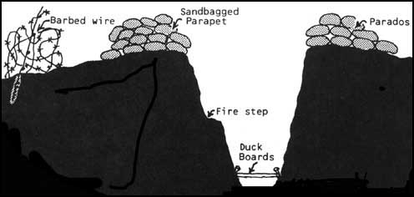
- What weapon killed the most people in World War I? ____________________________
- To protect themselves from artillery, what did soldiers build? ______________________
- What was the area between the trenches named? ________________________________
- In April of 1915, Germans first used what weapon? ______________________________
- What weapon did the British first use in 1915? __________________________________
- What is a Zeppelin? _______________________________________________________
- What was the average life expectancy of a pilot in World War I? ___________________
- What were American soldiers nicknamed? _____________________________________
- What is a convoy? ________________________________________________________
- Who overthrew the Russian provisional government in November 1917? _____________
- Germany’s last offensive tried to capture what city? ______________________________
- How close did the Germans get to this city? ____________________________________
- What is an armistice? ______________________________________________________
- On what date did the fighting during World War I end? ___________________________
- What was the name of the treaty that ended World War I with Germany? _____________
- What was the name of President Wilson’s peace plan? ____________________________
- The 14th point of Wilson’s plane was the creation of what? ________________________
- Define reparations? _______________________________________________________
- A treaty of the U.S. must be passed by the Senate with how much of a majority? _______
- What was the name given to the Senators who were against the treaty? _______________
Matching: People of World War I
21. |  | Alvin York | - American member of the “Big 4”
22. |  | Eddie Rickenbacker | - Italian Prime Minister during WW I
23. |  | John J. Pershing | - Fought in the Argonne Forest
24. |  | Woodrow Wilson | - Signed Treaty of Versailles for the British
25. |  | David Lloyd George | - American fighter pilot in World War I
26. |  | Georges Clemenceau | - Commander of American Expeditionary Force
27. |  | Vittorio Orlando | - Premier of France during World War I

True or False: The Fourteen Points
28. | Based on the principle of Justice to all peoples and Nationalities
29. | The first 5 points were to eliminate the causes of war
30. | The next 8 points addressed the right of national self-determination
31. | The 14th point was about the League of Nations
32. | The U.S. Senate accepted the 14 points

Essay: World War I is often called the first modern war. What were the new technologies used in this was and what were they used for? ________________________________________________________________________________________________________________________________________________________________________________________________________________________________________________________________________________________________________________________________________________________________________________________________________________________________________________________________________________________________________________________________________________________________________________________________________________________
Extra Credit: Who was the first Iowa serviceman to die during World War I? ___________________________________________________________________________

