Name ____________________ Date ____________________ Period ____________________
U.S. History
Chapter 9.2
The Home Front (pp.328-333)
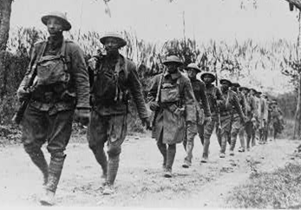
- What was the most important agency during World War I? ________________________
- What was the most successful agency during World War I? ________________________
- What was the Food Administration responsible for? ______________________________
- What did the Food Administration encourage families to do? ______________________
- How much did the US spend on the war effort? _________________________________
- The National War Labor Board helped to prevent what? __________________________
- How many women joined the workforce for the first time during the war? ____________
- The movement of African Americans to the North became known as? _______________
- How many Mexicans migrated to the American Southwest during the war? ___________
- Why was the Committee on Public Information created? __________________________
- Define espionage. _________________________________________________________
- What did the Sedition Act make illegal? _______________________________________
- What did the Selective Service Act make men do? _______________________________
- How many people did the influenza epidemic kill worldwide? _____________________
- How many African-Americans served overseas as combat troops? __________________
- World War I was the first war in which women did what? _________________________
Matching: Progressive Agencies
17. | War Industry Board |  | - Introduced daylight savings time
18. | Food Administration |  | - Encouraged victory gardens
19. | Fuel Administration |  | - Tried to sell the war to the people
20. | National War Labor Board |  | - Coordination of war production
21. | Committee on Public Information |  | - Mediated labor disputes

Matching: The number of…
22. | African Americans drafted |  | - 11,000
23. | Men who volunteered |  | - 20,000
24. | Nurses in the Army |  | - 200,000
25. | Women in the Navy |  | - 400,000
26. | Americans wounded |  | - 2,000,000

Essay
How did World War I, change life in the U.S. during World War I. _____________________________________________________________________________________________________________________________________________________________________________________________________________________________________________________________________________________________________________________________________________________________________________________________________________________________________________________________________________________________________________________________________________
Extra Credit:
What East High Alumni and Iowa Hawkeye All-American died in World War I? __________________________________________________________________________

