Name ____________________ Date ____________________ Period ____________________
U.S. History
Chapter 8.3
The Wilson Years (pp. 308-313)
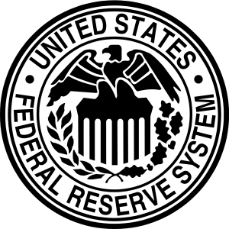
- The Progressive Party quickly became known as the: _____________________________
- Under Wilson, what state became a model of progressive reform? __________________
- What did Roosevelt call his program? _________________________________________
- Wilson countered with what he called the what? _________________________________
- Wilson won the Electoral College with how many votes? _________________________
- Wilson was the first president since John Adams to do what? ______________________
- Wilson believed that lowering tariffs would benefit whom? ________________________
- What amendment made the income tax possible? ________________________________
- The Federal Reserve Act created how many regional banks? _______________________
- The Federal Trade Commission was set up to monitor what? _______________________
- What did Samuel Gompers call the Clayton Antitrust Act? ________________________
- 12. The Adamson Act established the eight-hour workday for whom? _______________
- What did progressivism fail to address? _______________________________________
- Where did W.E.B. DuBois and other black leaders meet in 1905? ___________________
- What organization was founded in 1909? ______________________________________
- What city experienced a race riot in 1908? _____________________________________
- What other group, besides African Americans, faced discrimination? ________________
- Who founded the Anti-Defamation League? ____________________________________
Map Exercise: Consulting the map on page 311, complete the following list of cities with Federal Reserve Banks. Be sure to put them in alphabetical order.
1. |  | 7.
2. | Boston | 8. | New York
3. |  | 9.
4. | Cleveland | 10.
5. |  | 11. | Saint Louis
6. | Kansas City | 12. | San Francisco

True or False
1. | Roosevelt believed that Taft had failed to live up to progressive ideals. | T or F
2. | Wilson believed that monopolies should be regulated, not destroyed. | T or F
3. | The Federal Reserve Act was one of the most significant pieces of legislation in American history. | T or F
4. | Wilson opposed the creation of the Federal Trade Commission | T or F
5. | Wilson expanded the role of the federal government and the power of the president | T or F

Essay Question
How did progressivism make important changes in the political life of the United States? (See a “A New Kind of Government,” pp. 312-313).
_______________________________________________________________________________________________________________________________________________________________________________________________________________________________________________________________________________________________________________________________________________________________________________________
Extra Credit: President Wilson’s image was featured on what denomination bill? ___________________________________________________________________________

