Name ____________________ Date ____________________ Period ____________________
U.S. History
Chapter 8.2
Roosevelt and Taft (pp. 300-307)
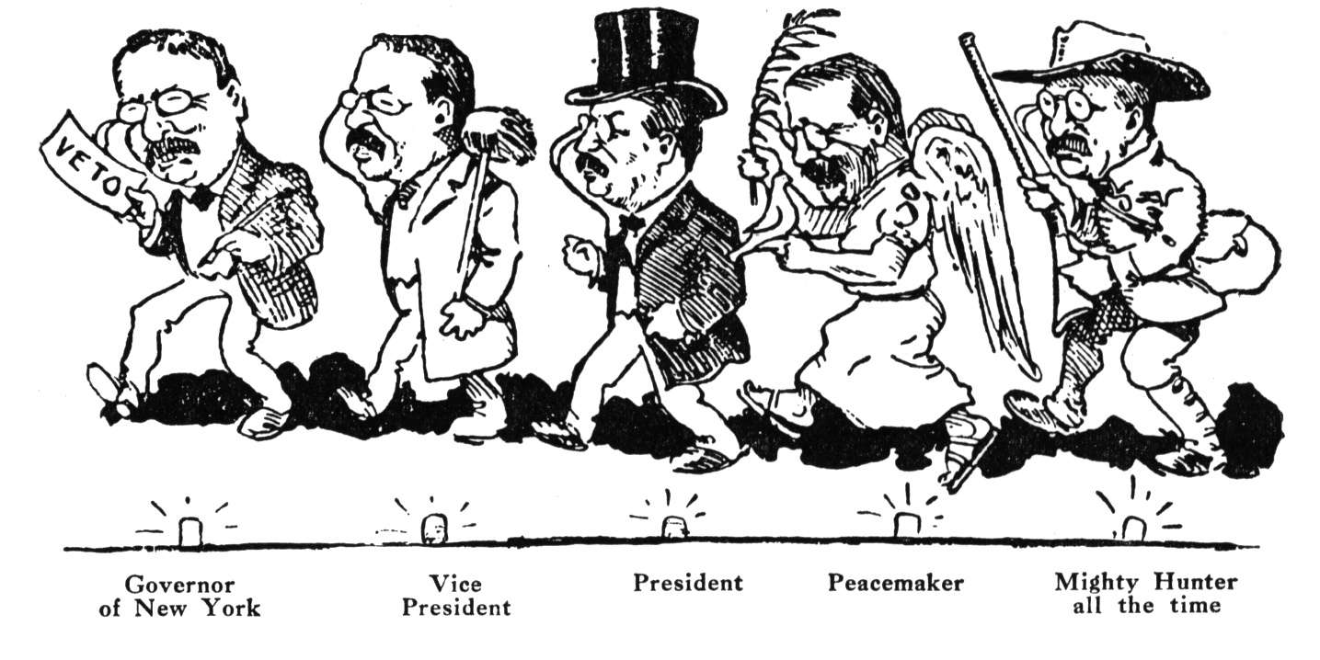
- Roosevelt’s reform programs became known as the what? _________________________
- What company was Roosevelt’s first target as a trustbuster? _______________________
- Define arbitration. ________________________________________________________
- In 1903 Roosevelt convinced Congress to create what? ___________________________
- The Hepburn Act gave to the ICC the power to set what? _________________________
- What journalist exposed the patent medicine business? ___________________________
- Who wrote The Jungle? ____________________________________________________
- Roosevelt put his stamp on the presidency most clearly in what area? ________________
- What 1902 act dealt with irrigation and land development? ________________________
- Whom did Roosevelt appoint to head the U.S. Forest Service? _____________________
- How many national parks did Roosevelt establish? ______________________________
- What did Roosevelt call his power to present his views? __________________________
- Whom did Taft defeat in the presidential election of 1908? ________________________
- Taft called Congress into special session to lower what? __________________________
- Whom did Taft appoint as secretary of the interior? ______________________________
- Taft fired Gifford Pinchot for what? __________________________________________
- What agency did Taft create to investigate child labor? ___________________________
- Where did Roosevelt go big-game hunting in 1909? ______________________________
True or False
19. | Theodore Roosevelt was both a Social Darwinist and a progressive | T or F
20. | Roosevelt and Gifford Pinchot believed that the best way to preserve public land was to sell it to lumber companies | T or F
21. | When he left the White House in 1909, Roosevelt believed William Howard Taft to be the ideal person to continue his policies | T or F
22. | Progressives were pleased with the Payne-Aldrich Tariff | T or F
23. | Taft’s contributions to conservation equaled or even surpassed those of Roosevelt | T or F

Time Line: Write 1 in front of the event that happened first, 2 in front of the one that happened second, etc.
24. |  | Roosevelt goes big game hunting in Africa
25. |  | Upton Sinclair publishes The Jungle
26. |  | In Northern Securities, The Supreme Court rules that Northern Securities had violated the Sherman Antitrust Act
27. |  | Democrats score a sweeping victory in congressional elections
28. |  | Roosevelt appoints Gifford Pinchot to head the U.S. Forest Service

Essay Questions
What was Roosevelt’s policy toward trusts? Discuss one example of the policy. _________________________________________________________________________________________________________________________________________________________________________________________________________________________________
Identify three reasons for Roosevelt’s break with Taft. _________________________________________________________________________________________________________________________________________________________________________________________________________________________________
Extra Credit: In what state is the Theodore Roosevelt National Park located? ___________________________________________________________________________

