Name ____________________ Date ____________________ Period ____________________
U.S. History
Chapter 7.3
New American Diplomacy (pp.276-283)
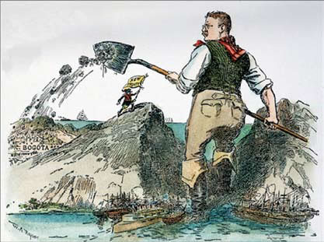
- America’s primary interest in Asia was not conquest but what? _____________________
- In 1894 war erupted between China and Japan over what region? ___________________
- What policy did McKinley and Hay support in China? ____________________________
- What secret society did Westerners refer to as Boxers? ___________________________
- How large was the international force that landed in China? _______________________
- What was McKinley’s 1900 campaign slogan? __________________________________
- In what city was President McKinley shot? _____________________________________
- How old was Theodore Roosevelt when he became president? _____________________
- What prize did Roosevelt win in 1906? ________________________________________
- Where was Roosevelt’s “big stick” policy most evident? __________________________
- In 1901 the U.S. and Great Britain signed what treaty? ___________________________
- In 1903 Panama was what country’s most northern province? ______________________
- Taft’s policy in Latin America came to be called what? ___________________________
- U.S. troops occupied what Central American country until 1925? ___________________
- What was Woodrow Wilson before entering politics? ____________________________
- In April 1914 American sailors were arrested in what Mexican city? ________________
- What U.S. town did Pancho Villa attack and burn? ______________________________
- How many troops did General Pershing lead into Mexico? ________________________
Matching: Match the following people with the correct description.
19. |  | Philippe Bunau-Varilla | - U.S. President inaugurated in 1913
20. |  | Leon Czolgosz | - General sent to capture Pancho Villa
21. |  | John Hay | - Mexican general who seized power in 1913
22. |  | Victoriano Huerta | - Organizer of an uprising in Panama
23. |  | John J. Pershing | - U.S. Secretary of State
24. |  | Pancho Villa | - Anarchist who assassinated McKinley
25. |  | Woodrow Wilson | - Leader of attack on Columbus, New Mexico

Quotes
26. Who said, “It would be the irony of fate if my administration had to deal chiefly with foreign affairs”
Name: ________________________________________________________________________
27. Who often used the expression “Speak softly and carry a big stick.”
Name: ________________________________________________________________________
28. Who said, “Now look, that **** cowboy is president of the United States!”
Name: ________________________________________________________________________
29. Who described his brand of diplomacy as “substituting dollars for bullets.”
Name: ________________________________________________________________________
Essay Question
Discuss the origin, the goals, and an example of the Roosevelt Corollary. ________________________________________________________________________________________________________________________________________________________________________________________________________________________________________________________________________________________________________________________
Extra Credit: What type of handgun did Leon Czolgosz use to kill President McKinley? ______________________________________________________________________________

