Name ____________________ Date ____________________ Period ____________________
U.S. History
Chapter 7.2
The Spanish-American War (pp.268-275)
Instructions: As you read pages 268–275 in your text book, complete this graphic organizer by listing the circumstances that contributed to war with Spain.

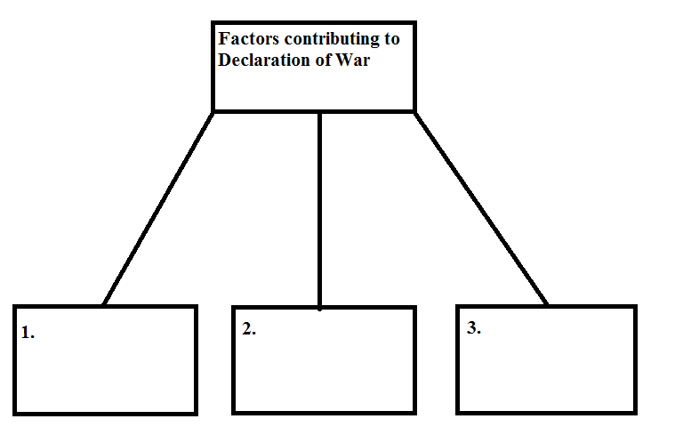

The Coming of War
Notes | Reading
Complete the sentence.  Spain offered Cuba autonomy because… | Cuba began fighting for independence from Spain in 1868. In 1878, the rebellion collapsed. Many rebels fled to the United States. Americans had invested millions of dollars in Cuba’s railroads and sugar plantations. They bought Cuban sugar. Then a new tariff on sugar caused the sale of Cuban sugar to fall. This hurt Cuba’s economy. Rebels rose up against Spain again in February 1895 and declared Cuba independent.  Americans read stories of Spanish brutality in newspapers. This sensational reporting became known as yellow journalism. Although many stories were exaggerated, Cubans suffered greatly. President McKinley warned Spain that the United States might intervene. Spain removed the Spanish governor of Cuba and offered Cuba autonomy, or self-rule, if it agreed to remain part of the Spanish empire. The Cubans refused.  In 1898, riots started in Havana. McKinley sent the battleship Maine to evacuate Americans in Cuba. When it exploded in Havana’s harbor, Americans blamed Spain. Jingoism, or aggressive nationalism contributed to the push for war. Congress declared war on Spain on April 19.

A War on Two Fronts
Notes | Reading
Compare how the U.S. Army and Navy performed during war.  U.S. Army:  U.S. Navy: | Spain was not prepared for war, but the U.S. Navy was. A U.S. Navy fleet blockaded Cuba. Another fleet attacked and destroyed the Spanish fleet in the Philippines. With the help of local rebels, the navy fleet took control of the Filipino capital, Manila.  The U.S. Army was not as ready for war as the navy was. However, on June 14, 1898, about 17,000 soldiers landed in Santiago, Cuba. A volunteer cavalry regiment called the “Rough Riders” accompanied them. They were a group of cowboys, miners, and law officers. Colonel Leonard Wood commanded them, and Theodore Roosevelt was second in command.  The Rough Riders and the army troops defeated the Spanish in two battles. The Spanish commander in Santiago ordered his fleet to leave the harbor. American warships attacked, sinking many ships. The Spanish in Santiago surrendered. Soon American troops occupied the Spanish colony of Puerto Rico.

An American Empire
Notes | Reading
Make a generalization about countries under imperialist rule. | After the war, Cuba obtained its freedom, and the United States annexed Guam and Puerto Rico. The question of what to do with the Philippines remained open. Some Americans pushed for annexing the Philippines. Others opposed it. When the United States signed the Treaty of Paris with Spain in 1898, it agreed to pay $20 million to annex the Philippines.  Although Cuba became independent, President McKinley made sure it remained tied to the United States. He allowed Cuba to set up a new constitution under conditions that effectively made Cuba a protectorate of the United States. These conditions became known as the Platt Amendment. Cuba reluctantly added the amendment to its constitution.  The United States had to decide how to govern Puerto Rico. At first it was governed by a U.S.-appointed official. Congress gradually gave Puerto Rico more self-government. The debate over whether Puerto Rico should become a state, an independent country, or remain a commonwealth continues today.  In the Philippines, rebels fought the United States for control of the islands. The United States responded by treating the Filipinos much like Spain had treated the Cubans. Thousands died in reconcentration camps. The United States instituted reforms in the Philippines, which eased Filipino hostility toward it. Over the years, the United States gave the Filipinos more control. It finally granted independence to the Philippines in 1946.

