Name ____________________ Date ____________________ Period ____________________
U.S. History
Chapter 6.5
The Rise of Segregation (pp. 248-253)
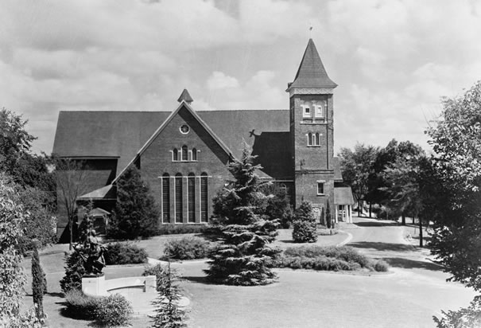
- Define sharecropper. ______________________________________________________
- Sharecropping usually left farmers in chronic what? _____________________________
- Who urged African Americans to leave the South? _______________________________
- How many African Americans left the South for Kansas? _________________________
- By what term did these migrants come to be known? _____________________________
- The Colored Farmers’ National Alliance had how many members? __________________
- In 1891 many African Americans joined what new organization? ___________________
- To win back the poor white vote, Democratic leaders appealed to what? ______________
- What amendment prohibits the denying the right to vote based on race? ______________
- In 1890 Mississippi began requiring voters to pay a what? _________________________
- Mississippi also instituted what kind of test for voters? ___________________________
- What provision exempted most whites from voting restrictions? ____________________
- Define segregation? _______________________________________________________
- What were the laws enforcing discrimination in the South called? ___________________
- In 1883 the Supreme Court overturned what law? _______________________________
- In 1892 who challenged a Louisiana segregation law? ____________________________
- What doctrine did the Supreme Court set out in Plessy v. Ferguson? ________________
- In the 1890s, what was the average number of lynchings per year? __________________
- Mary Church Terrell led a boycott against stores in what city? _____________________
- Booker T. Washington summed up his views in what speech? _____________________
Matching
21. |  | W.E.B. DuBois | a. encouraged emigration to Kansas
22. |  | Benjamin “Pap” Singleton | b. stressed importance of economic goals
23. |  | Mary Church Terrell | c. worked with human suffrage leaders
24. |  | Booker T. Washington | d. launched a crusade against lynching
25. |  | Ida B. Wells | e. author of The Souls of Black Folk

Essay Questions
How were Southern states able to deny the right to vote to African Americans, but not whites? ________________________________________________________________________________________________________________________________________________________________________________________________________________________________________________________________________________________________________________________________________________________________________________________________________________________________________________________________________________________________________________________________________________________________________________________________________________________________________________
Discuss the differing approaches of Booker T. Washington and W.E.B. DuBois to promoting the equality of African Americans. Which approach would you favor? Why? ________________________________________________________________________________________________________________________________________________________________________________________________________________________________________________________________________________________________________________________________________________________________________________________________________________________________________________________________________________________________________________________________________________________________________________________________________________________________________________
Extra Credit: What was the title of Booker T. Washington’s autobiography? ______________________________________________________________________________

