Name ____________________ Date _____________________ Period ___________________
U.S. History
Chapter 5.4
Unions (pp. 200-207)
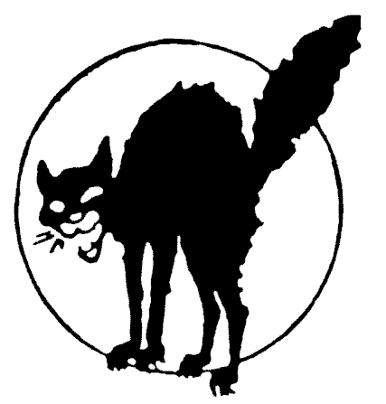
- In 1900 the average industrial worker made how much per hour? ___________________
- Name two basic types of industrial workers. ____________________________________
- By 1873 there were how many national trade unions in the U.S.? ___________________
- Employers generally viewed unions as what? ___________________________________
- Business leaders particularly opposed what type of unions? ________________________
- Whose ideas became influential in Europe in the 1800s? __________________________
- Anarchists believe that society does not need what? ______________________________
- The Great Railroad Strike eventually involved how many workers? _________________
- Who was the leader of the Knights of Labor? ___________________________________
- What event undermined the Knight’s reputation? ________________________________
- What agency did Frick hire to bring replacement workers? ________________________
- In 1893 what company laid off workers and slashed wages? _______________________
- In what case did the Supreme Court uphold injunctions? __________________________
- Who was the first president of the AFL? _______________________________________
- What were members of the IWW nicknamed? __________________________________
- In 1912 the IWW led a successful strike of textile workers where? __________________
- Whom did Rockefeller call “the most dangerous woman in America”? _______________
Definitions
- Deflation: _______________________________________________________________
- Blacklist: _______________________________________________________________
- Lockout: ________________________________________________________________
- Arbitration: _____________________________________________________________
- Injunction: ______________________________________________________________
Essay Questions
Discuss the differences between trade unions and industrial unions. ____________________________________________________________________________________________________________________________________________________________________________________________________________________________________________________________________________________________________________
What were some of the techniques employers to discourage unions? ____________________________________________________________________________________________________________________________________________________________________________________________________________________________________________________________________________________________________________
What were the goals of the Knights of Labor? ____________________________________________________________________________________________________________________________________________________________________________________________________________________________________________________________________________________________________________
Extra Credit: Who said, “Workingmen of all countries, unite!” ___________________________________________________________________________

