Name ____________________ Date ____________________ Period ____________________
U.S. History
Chapter 5.2
The Railroads (pp. 188-193)
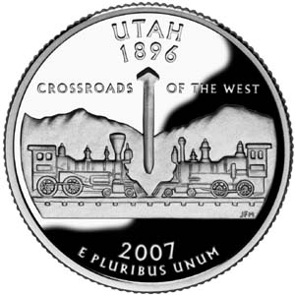
- In 1865 how many miles of railroad track did the U.S. have? _______________________
- By 1900 how many miles of track did the U.S. have? _____________________________
- Who signed the Pacific Railway Act of 1862? __________________________________
- What railroad pushed west from Omaha, Nebraska? ______________________________
- At its height, the Union Pacific employed how many workers? _____________________
- The Central Pacific Railroad was the dream of what engineer? _____________________
- The Central Pacific hired 10,000 workers from what country? ______________________
- Workers completed the transcontinental railroad in how many years? ________________
- How many miles of track did the Union Pacific lay? _____________________________
- Who hammered the last spike? ______________________________________________
- At what place in Utah were the final rails joined? ________________________________
- Who was the most successful railroad consolidator? _____________________________
- The American Railway Association divided the country into four what? ______________
- What did the federal government give to many railroad companies? _________________
- Who was infamous for manipulating stock? ____________________________________
- What scandal erupted in 1872? ______________________________________________
- What vice president accepted Credit Mobilier stock? _____________________________
- Who built and operated the Great Northern Railroad? ____________________________
Matching: Match the following people with the correct description.
19 |  | Grenville Dodge |  | - Built New York’s Grand Central Terminal
20 |  | Jay Gould |  | - Founded a famous California university
21 |  | James J. Hill |  | - Former Union General and railroad builder
22 |  | Leland Stanford |  | - Most notoriously corrupt railroad owner
23 |  | Cornelius Vanderbilt |  | - Built a railroad without any land grants

Definitions: Define the following terms.
24. Pacific Railway Act _______________________________________________________
25. “Big Four” ______________________________________________________________
26. Land grants ______________________________________________________________
27. Robber Barons ___________________________________________________________
28. Credit Mobilier ___________________________________________________________
Technology & History (p. 190)
Discuss four ways the construction of the railroads had a “multiplier effect” on the American economy.
__________________________________________________________________________________________________________________________________________________________________________________________________________________________________________________________________________________________________________________________________________________________________________________________________________________________________________________________________
Extra Credit Who was Casey Jones? What did he do that made him a railroad legend?
______________________________________________________________________________________________________________________________________________________

