Name ____________________ Date ____________________ Period ___________________
U.S. History
Chapter 4.3
Native Americans (pp.170-175)
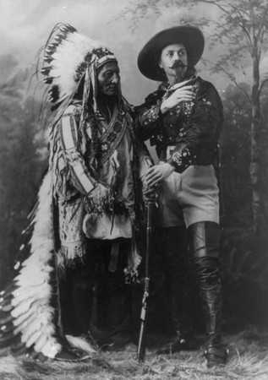
- Who forced Native Americans to relocate and deprived them of their hunting grounds? _______________________________________________________________ (3 Points)
- Who was the Sioux chief in 1862 that reluctantly started an uprising in Minnesota against soldiers and also civilians? ___________________________________________
- Name three Lakota Chiefs who had battled rival groups and did not intend to let settlers get control of the Black Hills? _______________ _______________ _______________
- Who was the Cheyenne Chief who brought several hundred Native Americans to Fort Lyon to negotiate a peace deal? ______________________________________________
- In 1867 Congress proposed creating two large reservations on the plains. What is the name of this commission? __________________________________________________
- Who was the Lieutenant Colonel who took the Seventh Cavalry and launched a three pronged attacked on the largest Native American warriors ever assembled? ________________________________________________________________________
- In 1877, Chief Joseph of Nez Perce people surrendered and his followers were exiled to what state? ______________________________________________________________
- Who was the great Lakota Chief who supported the Ghost Dance, a ritual that celebrated a hope for settlers to disappear, and was killed at Wounded Knee? __________________
- Some Americans wanted the Native American to ___________________ or be absorbed in American Society.
- The federal government fought several wars with Native Americans, established reservations, and finally passed the ______________ Act to assimilate Native Americans.
Matching
11. |  | Sand Creek Massacre | - Nez Pierce Chief who surrendered after a flight of 1,300 miles
12. |  | Indian Peace Commission | - Gave Native Americans land for farming
13. |  | George A. Custer | - Put Native Americans on reservations
14. |  | Chief Joseph | - Lost the Battle of the Little Bighorn
15. |  | Dawes Act | - Cheyenne came to Fort Lyon to negotiate

Short Answer: Compare and Contrast how the Native Americans wanted to use the Great Plains and how the American settlers wanted to use the Great Plains.
______________________________________________________________________________________________________________________________________________________________________________________________________________________________________________________________________________________________________________________________________________________________________________________________________________________________________________________________________________________________________________________________________________________________________________________________________________________________________________________________________________________________________________________________________________________________________________________________________________________________________________________________________________________________________________________________________________________________________________________________________________________________________________________________________________________________________________________________________________________________________________________________________________________________________________________________________________________________________________________________________________________________________________________________________
Extra Credit: George A. Custer graduated from West Point. What was his class ranking?
___________________________________________________________________________

