Name ____________________ Date _____________________ Period ___________________
U.S. History
Chapter 4.2
Farming the Plains (p.166-169)
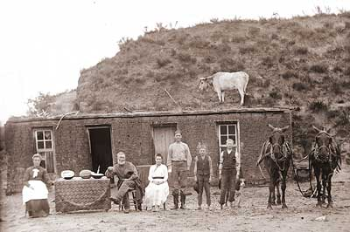

- To obtain water, Homesteaders had to drill wells and ____________________________.
- He jokingly said “If you can’t beat ’em, eat ‘em.” _______________________________.
- The Great Plains are dry grassland where trees grow along __________ and __________.
- During the 1800’s, one important factor was the construction of ____________________.
- For more than a decade in the 1870s, what fell on the plains? ______________________
- This allowed one to claim up to 160 acres of land? _______________________________
- Settlers found life difficult on the plains, the faced temperatures __________________F.
- A method of farming where seeds were planted deep in the ground. _________________
- Those who plowed the plains were called ___________________________.
- This began at the eastern edge of the Great Plains to much of the Dakotas. ____________
- Some wheat farms covered up to 50,000 acres, were called _______________________.
- By the 1880’s, the U.S. had become the leading exporter of what? __________________
- In the late 1880’s, what occurred that destroyed crops? ___________________________
- By 1900, tenants cultivated how much of the farms of the Plains? ___________________
- On April 22, 1889, the government opened up one of the last territories for settlement, known as? ___________________________
- What year did the Census Bureau report the closing of the frontier? _________________
- The closing of the frontier worried many, but especially, _________________________.
- According to Turner, the frontier was a place where Americans could always? _____________________________________________________________________
Using page 167 in your text book, answer the following questions.
- What were the requirements of the Homestead Act?
- _____________________________________________________________
- _____________________________________________________________
- _____________________________________________________________
- _____________________________________________________________
- _____________________________________________________________

Use the map on page 167 to answer the following questions.
- In what region of the country were both cattle raised and cotton grown? _______________________________________________________________________
- Farming in Iowa was known for what ______________________________________ and _________________________________________.

Use information from this section to list the effects of technology on farming in the Great Plains.
Invention | Advantage for farmers
22. | 23.
24. | 25.
26. | 27.

