Name ____________________ Date ____________________ Period ____________________
U.S. History
Chapter 19.3
The War Winds Down (pp.670-675)
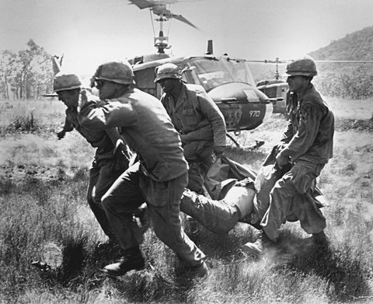
- Who was Nixon’s special assistant for national security? __________________________
- How many years did Kissinger’s negotiations with Le Duc Tho drag on? _____________
- Nixon ordered the secret bombing of Vietcong sanctuaries where? __________________
- Who massacred unarmed South Vietnamese civilians? ____________________________
- How many students were killed at Kent State University? _________________________
- What did an angry Congress repeal in December 1970? ___________________________
- Who leaked the Pentagon Papers? ____________________________________________
- By 1971, how many Americans wanted to end the Vietnam War? ___________________
- Who was the Democratic candidate for president in 1972? ________________________
- What percent of the popular vote did Nixon win? ________________________________
- For how many straight days did American B-52s bomb North Vietnam? _____________
- When did the warring sides sign an agreement to end the war? _____________________
- When did North Vietnam launch a full-scale invasion of the South? _________________
- Who was the U.S. president by then? _________________________________________
- What did the Communists rename Saigon? _____________________________________
- The War resulted in the death of how many American soldiers? ____________________
- When did the nation dedicate the Vietnam Veterans Memorial? ____________________
- What act did Congress pass in 1973? _________________________________________
Short Answers

- Explain Henry Kissinger’s policy of linkage. ________________________________________________________________________________________________________________________________________________
- Describe President Nixon’s program of Vietnamization. ________________________________________________________________________________________________________________________________________________
- What did the Pentagon Papers reveal? ________________________________________________________________________________________________________________________________________________
- How did the War Powers Act limit Presidential authority? ________________________________________________________________________________________________________________________________________________

True or False
23. | Henry Kissinger, Nixon’s special assistant for national security, sought to improve U.S. relations with the Soviet Union and China. | T or F
24. | “Vietnamization” involved a gradual increase in the number of American troops in Vietnam. | T or F
25. | The demonstrations at Kent State University in May 1970 were in response to the My Lai Massacre. | T or F
26. | The Pentagon Papers, published in the New York Times, weakened public support for the war in Vietnam. | T or F
27. | In March 1975, South Vietnam launched a full-scale invasion of North Vietnam | T or F
28. | Many Americans considered the Vietnam War a defeat and wanted to forget about it. | T or F
29. | Since the passage of the War Powers Act, every President has asked Congress to authorize the use of military force before committing ground troops to combat. | T or F

Extra Credit
Who is the girl in the picture on page 671? ______________________________________________________________________________

