Name ____________________ Date ____________________ Period ____________________
U.S. History
Chapter 19.2
Vietnam Divides the Nation (pp. 664-669)
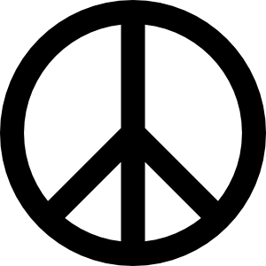
- What percent of Americans approved of the policy in Vietnam? ____________________
- Who argued that Vietnam was not strategically important? ________________________
- Where did faculty members and students hold a teach-in in March 1965? _____________
- Young protesters focused on what they saw as an unfair what? _____________________
- Draftees made up what percent of battlefield deaths? _____________________________
- African Americans accounted for what percent of combat-related deaths? ____________
- How many draftees refused to go? ____________________________________________
- The draft became less of an issue when the government introduced what system? ________________________________________________________________________
- What amendment lowered the voting age to 18? _________________________________
- What was the most turbulent year of the chaotic 1960s? ___________________________
- When was the Tet Offensive launched? ________________________________________
- What newscaster predicted the war would end in a stalemate? ______________________
- Who won 40% of the votes in New Hampshire? _________________________________
- When was Robert Kennedy gunned down? _____________________________________
- Where was the Democratic National Convention held? ___________________________
- Nixon won the 1968 election by how many electoral votes? _______________________
- Who won 46 electoral votes and 13% of the popular vote? ________________________
Definitions: Define the following terms
- Credibility gap ___________________________________________________________
________________________________________________________________________
- Doves __________________________________________________________________
________________________________________________________________________
- Hawks _________________________________________________________________
________________________________________________________________________
Map Exercise: Consulting the map on p. 668, answer the following questions.
- In what part of the country was Wallace’s support the greatest? ____________________
- Which candidate won Iowa? ________________________________________________
- What Southern state did Humphrey win? ______________________________________
- How many more electoral votes did Nixon receive than Humphrey? _________________
- In what part of the country was Humphrey’s support strongest? ____________________
Matching
26. |  | Hubert Humphrey | - Anti-war senator assassinated while campaigning for the 1968 Democratic presidential nomination
27. |  | Robert F. Kennedy | - Alabama governor and outspoken segregationist who ran for president as an independent
28. |  | Eugene McCarthy | - Little-known senator from Minnesota who won more than 40% of the vote in the 1968 New Hampshire primary
29. |  | Richard Nixon | - Democrat who narrowly lost the 1968 presidential election with 42.48% of the popular vote
30. |  | George Wallace | - Republican who ran for president in 1968, declaring that he had a plan for ending the war in Vietnam

Extra Credit
Who was the Democratic vice-presidential candidate in 1968? ___________________________

