Name ____________________ Date ____________________ Period ____________________
U.S. History
Chapter 19.1
Going to War in Vietnam (p. 654-661)
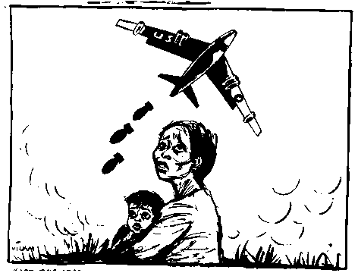
- Vietnam, Laos, and Cambodia were known collectively as what? ___________________
- What name did Nguyen Tat Thanh assume? ____________________________________
- What U.S. president formulated the “domino theory”? ____________________________
- The Vietminh frustrated the French with what tactics? ____________________________
- When did the French force at Dien Bien Phu fall to the Vietminh? __________________
- The Geneva Accords divided Vietnam along what parallel? ________________________
- How many Catholics fled North Vietnam? _____________________________________
- The guerrilla army of South Vietnamese Communists was called what? ______________
- From 1961 to 1963, the number of American military personnel in South Vietnam jumped from 2,000 to how many? ____________________________________________
- Diem discriminated against what religion? _____________________________________
- What did a group of generals seize power of in South Vietnam? ____________________
- When did Congress pass the Gulf of Tonkin Resolution? __________________________
- What base did Vietcong attack in February 1965? _______________________________
- What was the bombing campaign against North Vietnam called? ___________________
- By the end of 1965, how many American troops were in Vietnam? __________________
- What is napalm? __________________________________________________________
- What was North Vietnam’s network of jungle paths called? _______________________
- From what countries did North Vietnam receive support? _________________________
Definitions: Define the following terms.
- French Indochina _________________________________________________________
_______________________________________________________________________
- Domino Theory __________________________________________________________
________________________________________________________________________
- Guerrillas _______________________________________________________________
________________________________________________________________________
- Strategic Hamlets _________________________________________________________
________________________________________________________________________
- Gulf of Tonkin Resolution __________________________________________________
________________________________________________________________________
Matching
24. |  | Ngo Dinh Diem | - Leader of North Vietnam
25. |  | Dwight Eisenhower | - Leader of South Vietnam
26. |  | John F. Kennedy | - U.S. Ambassador to South Vietnam
27. |  | Henry Cabot Lodge | - President who enunciated the Domino Theory
28. |  | Ho Chi Minh | - President who increased U.S. troop strength in South Vietnam to 21,000

True or False
29. | The Geneva Accords called for elections to reunite Vietnam | T or F
30. | The strategic hamlets program was popular in South Vietnam | T or F
31. | By passing the Gulf of Tonkin Resolution, Congress handed its war powers to the president | T or F
32. | Agent Orange is a chemical used to stimulate crop growth | T or F
33. | President Johnson ordered full-scale attacks on the Ho Chi Minh Trail | T or F

Extra Credit
What was the capital of South Vietnam? _____________________________________________

