Name ____________________ Date ____________________ Period ____________________
U.S. History
Chapter 15.2
The Early Cold War Years (p.538-545)
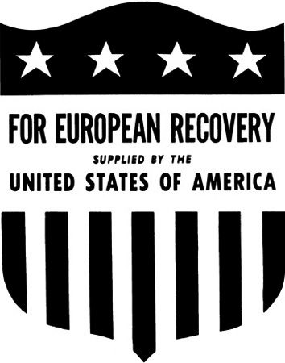
- British and American officials pushed for what in Eastern Europe? _________________
- Who proposed the basic American policy of containment? ________________________
- U.S. Pressure forced the Soviets to withdraw from what oil rich nation? ______________
- What straits did Stalin want to control? ________________________________________
- Truman asked for $400 million to fight Communist aggression in what two countries? ________________________________________________________________________
- The Marshall Plan was intended to rebuild Europe’s what? ________________________
- The Federal Republic of Germany became known as what? ________________________
- How many tons of supplies were airlifted into West Berlin? _______________________
- How many countries initially joined NATO? ___________________________________
- What military alliance did the Soviet Union organize? ____________________________
- The defeated Chinese Nationalists fled to what small island? _______________________
- What did the Soviet Union successfully test in September 1949? ____________________
- The Allies divided Korea at what parallel of latitude? ____________________________
- When did North Korean troops invade South Korea? _____________________________
- General MacArthur ordered a daring invasion at what port? _______________________
- What river did the Chinese troops cross in November 1950? _______________________
- Truman fired MacArthur for what? ___________________________________________
- How many American soldiers died in action in the Korean War? ___________________
Matching
19. |  | Chiang Kai-shek | - Proposed European Recovery Program
20. |  | George Kennan | - Author of the Long Telegram
21. |  | Douglas MacArthur | - U.S. commander in Korea
22. |  | George Marshall | - Chinese Communist leader
23. |  | Mao Zedong | - Chinese Nationalist leader

True or False
24. | The Soviet Union accepted the Marshall Plan aid | T or F
25. | Truman believed Europe’s prosperity depended on Germany’s recovery | T or F
26. | West Germany was not allowed to have a military | T or F
27. | In China, the U.S. supported the Nationalists | T or F
28. | The Korean War began when the South attacked the North | T or F

Essay Question
What was the Truman Doctrine? Discuss one example of the Truman Doctrine in action. ________________________________________________________________________________________________________________________________________________________________________________________________________________________________________________________________________________________________________________________
Discuss the differences between President Truman and General MacArthur in the conduct of the Korean War.
________________________________________________________________________________________________________________________________________________________________________________________________________________________________________________________________________________________________________________________
Extra Credit: What nation received the largest amount of Marshall Plan aid? ______________________________________________________________________________

