Name ____________________ Date ____________________ Period ____________________
U.S. History
Chapter 14.5
The War Ends (p.518-525)
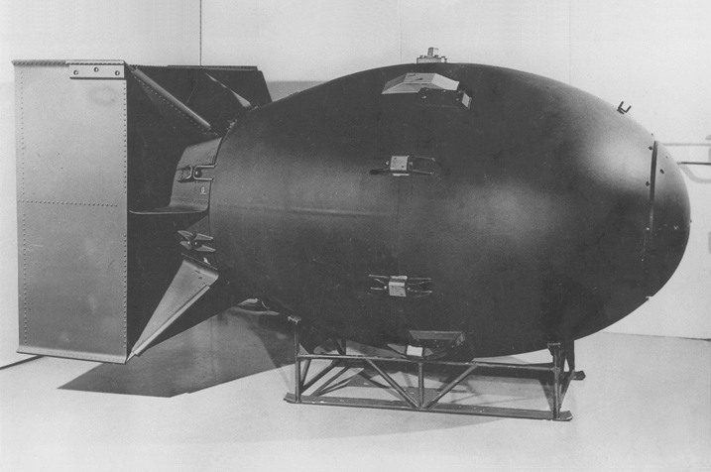
- Define Hedgerow. ________________________________________________________
- When did the Allied forces liberate Paris? _____________________________________
- What was the name of the last German offensive? _______________________________
- Who did General Eisenhower send to rescue the Allied troops? _____________________
- On May 7, 1945, the Germans surrendered. What was the next day called? ___________
- What did President Roosevelt die of? _________________________________________
- Who was the next President of the United States? _______________________________
- What island was chosen for the refueling of B-29 bombers? _______________________
- How many marines landed on Iwo Jima on February 19, 1945? _____________________
- Define Napalm. __________________________________________________________
- Napalm was designed to do what? ____________________________________________
- Why were the firebombs controversial? _______________________________________
- What was the Manhattan Project? ____________________________________________
- The Manhattan Project was headed by whom? __________________________________
- The first atomic bomb was dropped on what Japanese city? ________________________
- What was the code name for the first atomic bomb? ______________________________
- The second atomic bomb was dropped on what city? _____________________________
- What was the code name for the second atomic bomb? ___________________________
- The day Japan surrendered was called what? ___________________________________
- Who was the first chair of the Commission on Human Rights? _____________________
Matching
21. |  | Admiral William Leahy | - Wanted to surrender to the Allies, but keep fighting the Soviets
22. |  | General George Patton | - Split the uranium atom
23. |  | Harry S. Truman | - Liberated Allied forces in the Battle of the Bulge
24. |  | Admiral Karl Doenitz | - Roosevelt’s Vice-President
25. |  | Leo Szilard | - Believed economic sanctions and conventional bombing would make Japan surrender

Dates: Write the dates (month, day and year) for the following events:
26. The U.S. Marines land at Iwo Jima. ________________________________________________________________________
27. President Roosevelt died. ________________________________________________________________________
28. Hitler’s last offensive. ________________________________________________________________________
29. V-E Day ________________________________________________________________________
30. V-J Day ________________________________________________________________________
31. American troops land on Okinawa. ________________________________________________________________________
32. Representatives from 50 countries organized the United Nations charter. ________________________________________________________________________
33. The Enola Gay dropped the Atomic bomb on Hiroshima. ________________________________________________________________________
34. The surrender ceremony of the Japanese on the USS Missouri. ________________________________________________________________________
35. American troops capture Okinawa. ________________________________________________________________________
Extra Credit: Where was the first atomic bomb tested? __________________________

