Name ____________________ Date ____________________ Period ____________________
U.S. History
Chapter 14.4
Pushing Back the Axis (p.508-515)
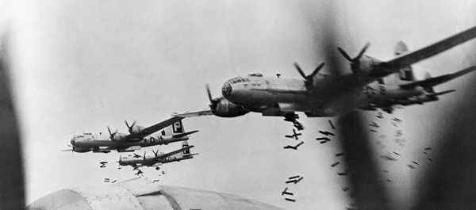
- Where did Roosevelt and Churchill meet in January 1943? ________________________
- What did Churchill call the “soft underbelly of Europe?” __________________________
- Between January 1943 and May 1945, how many tons of explosives did the Allies drop on Germany every month? __________________________________________________
- Who commanded the invasion of Sicily? ______________________________________
- Who arrested Mussolini on July 25, 1943? _____________________________________
- The Italian campaign cost the Allies how many casualties? ________________________
- Where did Roosevelt, Churchill, and Stalin meet late 1943? _______________________
- What was the allied code name for the invasion of France? ________________________
- By spring 1944, how many American soldiers were in England? ___________________
- The date of the invasion came to be known as what? _____________________________
- On which beach did the Allies experience the most intense German fire? _____________
- Many of the islands in the central Pacific were what? _____________________________
- What part of the Gilbert Islands was the Navy’s first objective? ____________________
- What vehicle made island landings safer and easier? _____________________________
- What was the largest naval battle in history? ____________________________________
- What does “kamikaze” mean? _______________________________________________
Who am I?
- Striding ashore on the island of Leyte in the Philippines, I declared, “People of the Philippines, I have returned. By the grace of Almighty God, our forces stand again on Philippine soil.” ________________________________________________________________________
- As commander of the American forces landing at Omaha and Utah beaches in Normandy, I feared at first that German resistance would force us to evacuate in defeat. But then the tide of battle shifted. ________________________________________________________________________
- At the Casablanca Conference, I convinced President Roosevelt that the Allies should attack Italy – the “soft underbelly of Europe” – before undertaking a cross Channel invasion. The Italians, I was sure, would quit the war if we invaded their homeland. ________________________________________________________________________
- As commander of the U.S. Pacific Fleet, I advanced through the central Pacific by “hopping” from island to the next, closer and closer to Japan. ________________________________________________________________________
- As the general in charge of Operation Overlord, I looked over the weather reports one last time just after midnight on June 6, 1944, and said, “OK, we’ll go.” ________________________________________________________________________
Reading a Map: Consulting the map on p.509, identify the country the following military actions took place.
22. | Battle of Kasserine Pass
23. | Battle of Stalingrad
24. | Operation Market Garden
25. | Allied landing at Anzio
26. | D-Day invasion

Extra Credit: “Mulberry” was the code name for a device used in the D-Day invasion. Explain what the device was.
______________________________________________________________________________

