Name ____________________ Date ____________________ Period ____________________
U.S. History
Chapter 14.2
The Early Battles (p.494-499)
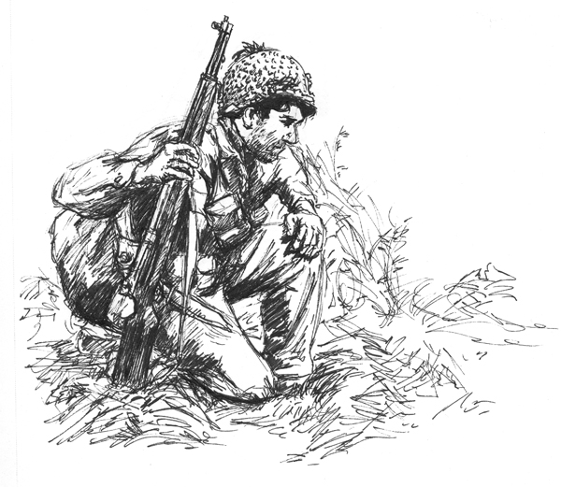
- What U.S. Navy vessels survived the attack on Pearl Harbor? ______________________
- American Troops in the Philippines retreated to what peninsula? ___________________
- How many troops died on the Bataan Death March? _____________________________
- What island in Manila Bay held out until May 1942? _____________________________
- What aircraft carrier launched Doolittle’s B-25s? ________________________________
- What two carriers intercepted the Japanese at Coral Sea? __________________________
- What Admiral had been waiting to ambush the Japanese fleet? _____________________
- How many carriers did the Japanese lose in the Battle of Midway? __________________
- Who urged Roosevelt to open a second front in Europe? __________________________
- In July 1942 Roosevelt ordered the invasion of: _________________________________
- Why did England need Egypt? ______________________________________________
- What U.S. general captured the city of Casablanca? ______________________________
- The U.S. suffered how many losses in the Battle of Kasserine Pass? _________________
- When did the last German troops in North Africa surrender? _______________________
- By August 1942, how many U.S. ships were sunk along the East Coast? _____________
- The loss of so many ships convinced the Navy to set up what system? _______________
- What Soviet city controlled the Volga River? ___________________________________
- In the Battle of Stalingrad, each side lost how many troops? _______________________
Matching
19. |  | James Doolittle | - Captured Casablanca
20. |  | Dwight D. Eisenhower | - Led U.S. air raid on Tokyo
21. |  | Douglas MacArthur | - Led invasion of North Africa
22. |  | George Patton | - U.S. commander in the Philippines
23. |  | Chester Nimitz | - Commander of U.S. Navy in Pacific

Essay Question: The three Allied leaders- Roosevelt, Churchill, and Stalin- all had their own ideas about how to wage the war. Explain their differences. (See page 497) _______________________________________________________________________________________________________________________________________________________________________________________________________________________________________________________________________________________________________________________________________________________________________________________
Short Answer
Why and how did the Doolittle Raid on Tokyo change Japanese war strategy? ____________________________________________________________________________________________________________________________________________________________________________________________________________________________________________________________________________________________________________
How was the U.S. able to win the Battle of the Atlantic? ____________________________________________________________________________________________________________________________________________________________________________________________________________________________________________________________________________________________________________
Extra Credit: What American General in World War II was known as “Old Blood and Guts?”
___________________________________________________________________________

