Name _____________________ Date ____________________ Period ___________________
U.S. History
Chapter 14.1
Mobilizing for War (p.486-493)
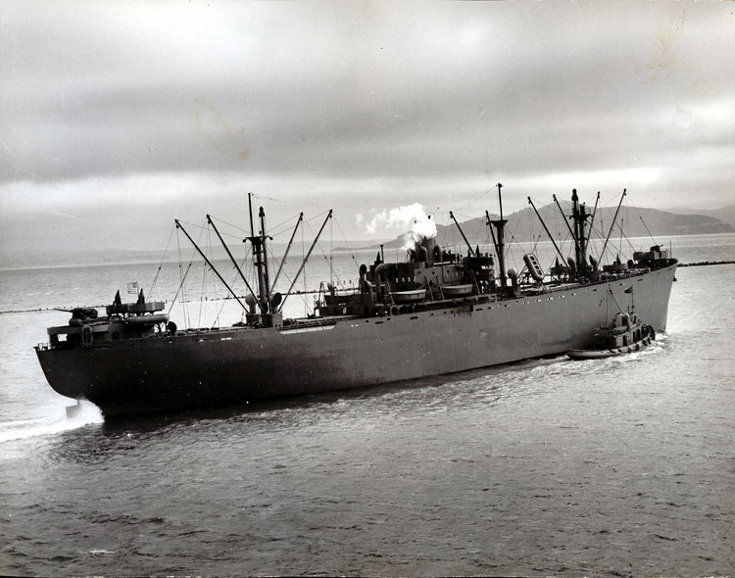
- Churchill knew that victory in modern war depended on what? _____________________
- In 1940 Roosevelt announced a plan to build how many airplanes a year? ____________
- What committee was created to mobilize the economy? ___________________________
- What convinced many companies to convert to war production? ____________________
- Automobile factories began producing what? ___________________________________
- What bomber was built at Henry Ford’s Willow Run plant? _______________________
- What was the basic cargo ship used during World War II? _________________________
- The average time to produce one of these ships dropped to how many days? __________
- What did the initials OWM stand for? _________________________________________
- How many men enlisted in the month after Pearl Harbor? _________________________
- What did “G.I.” stand for? __________________________________________________
- Recruits went to basic training for how many weeks? ____________________________
- Who had separate barracks, latrines, mess halls, etc.? _____________________________
- What campaign urged African Americans to support the war? ______________________
- Pilots of the 99th Pursuit Squadron became known as the what? _____________________
- When did the military integrate military bases? _________________________________
- Who were not allowed to serve in the military at first? ____________________________
- Most minorities were allowed only in what positions? ____________________________
- Who were regarded as fierce warriors? ________________________________________
- In May 1942, Congress first allowed who in the military? _________________________
Matching
21. |  | Benjamin O. Davis, Sr. | - Shipbuilder
22. |  | Oveta Culp Hobby | - Secretary of War
23. |  | Henry Kaiser | - Army Chief of Staff
24. |  | George C. Marshall | - Head of Women’s Army Corps
25. |  | Henry Stimson | - Highest-ranking African American

Charts and Graphs: See “U.S. Output of Military Products” on p.487and “U.S. Armed Forces” on p.490
26. What year did the production of combat aircraft peak? ____________________________
27. What year did the production of tanks peak? ____________________________________
28. How many ships were produced in 1944? ______________________________________
29. What branch of service recruited the fewest men? _______________________________
30. How many men were in the Army in 1945? ____________________________________
Short Answer
Explain how “Cost-plus” contracts helped increase war production. ______________________________________________________________________________________________________________________________________________________
Explain how the Reconstruction Finance Corporation helped increase war production. ______________________________________________________________________________________________________________________________________________________
Besides vehicles, what else did automobile factories produce during the war? ______________________________________________________________________________________________________________________________________________________
Extra Credit: There are several theories about how the jeep got its name. Tell one. ______________________________________________________________________________________________________________________________________________________

