TIME -
July 21, 1967
RACES Sparks & Tinder
As unlikely a place as Waterloo, a nice, small city of 75,000 in northeast Iowa' dairy area, was touched, too, by the madness. Waterloo's Negroes make up only 8% of the population, are well integrated into the schools, and enjoy an unemployment rate of a minimal 2.3% (well below the current national average of 4%). But trouble exploded anyway. A young Negro, in full view of a prowl car, deliberately knocked down an old white man who was sweeping the sidewalk in front of a tavern. His arrest touched off yet another 48 hours of rioting by Negro youths--to the perplexity of their elders. Said Albert Morehead, 68, a Mississippi-reared Negro who takes pride in the symbols of his success in the North--a neat frame house and around it flourishing patches of greens and flowers,: "I can't see no call for it."
Once it flared, the most striking feature of Newark's riot--like those in a score of other cities--was that the young Negroes took it over. Some were seekers of kicks. Some, still in their teen's were already infected with hate. And some were, in an extreme fashion, reflecting a yawning generation gap--the sort of thing that high school student Byron Washington, 16, was talking about when he said in Waterloo, Iowa: "The whites got to face it, man. This is a new generation. We aren't going to stand for the stuff our mas and fathers stood for."

Winter 2006 »
print | email

Burn, Bébé, Burn
By Thomas J. Sugrue

American cities exploded in violence in July 1967. First came Newark, where thousands took to the streets on July 12, after a clash between a black taxi driver and the police. After nearly a week of violence, the toll was twenty-three people dead and millions of dollars of property destroyed. Even more devastating was the uprising in Detroit that began early on the morning of July 23, when police raided an after-hours bar. After six days of arson, looting, and sniping, forty-three people were dead. Eventually seventeen thousand law-enforcement officials were deployed to put down the violence, including the National Guard and the elite 101st Airborne (the same military unit that had been dispatched to calm white-supremacist rioting when Little Rock, Arkansas, desegregated its public schools). Unrest spread to black neighborhoods throughout the country. Including Detroit and Newark, altogether 103 riots broke out throughout the United States that July—in cities as large as Cleveland, Ohio, and Philadelphia, Pennsylvania; in middle-sized places such as Fresno, California, and South Bend, Indiana; and even in small towns such as Nyack, New York; Plainfield, New Jersey; and Waterloo, Iowa.
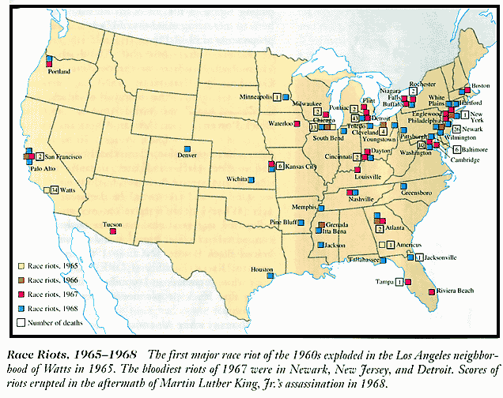

In 1910 black workers were brought to Waterloo, Iowa to break a railroad strike.
July 10th stoned cars and looted stores waterloo iowa
Newark, July 1967. Violence exploded when blacks heard and believed a false rumor that the police had killed a black taxi driver. As the rioting spread, exaggerated reports of black snipers prompted the intervention of the National Guard. In six days of rioting, 26 were killed, 1,500 injured, and damage reached $30 million.
Detroit, July 1967. The worst riot of the decade erupted on a muggy night when police raided an after-hours drinking club. At the height of the violence, President Lyndon Johnson sent in the U.S. Army, and the National Guard fired machine guns from Sherman tanks. The seven-day toll: 43 killed, 2,000 injured, 7,000 arrested and 5,000 left homeless.
Read more: http://www.time.com/time/magazine/article/0,9171,924145,00.html#ixzz1KefVnbeO

