Name ____________________ Date ____________________ Period ____________________
U.S. History
Chapter 9.1
The United States Enters World War I (pp.320-327)
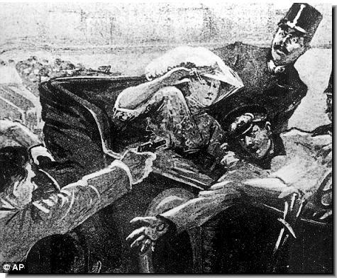
- The roots of World War I date back to when? ___________________________________
- When was the German Empire born? _________________________________________
- What three countries became part of the Triple Alliance? (3 Points) ________________________________________________________________________
- What is militarism? _______________________________________________________
- What three countries became part of the Triple Entente? (3 Points) ________________________________________________________________________
- Define Nationalism. _______________________________________________________
- Nationalists place high emphasis on what? _____________________________________
- Define Imperialism. _______________________________________________________
- In what city was Franz Ferdinand assassinated? _________________________________
- Why did Britain declare war on Germany? _____________________________________
- At the beginning of WWI, what did Wilson immediately declare the U.S.? ____________
- What two groups of Americans supported the Central Powers? _____________________
- American business interests favored which side? ________________________________
- In response to a British blockade, what did the Germans develop? __________________
- What pledge kept the U.S. out of World War I? _________________________________
- What was the Zimmermann telegram? ________________________________________
Alliances: List the countries of each alliance.
Allies | Central Powers
17. | 21.
18. | 22.
19. | 23.
20. | 24.

Cause and Effect: List the effect for each cause.
25. Austria-Hungary declares war on Serbia: _________________________________________
26. Franz Ferdinand is assassinated: ________________________________________________
27. German troops cross Belgian frontier: ____________________________________________
Paragraph:
Why

