Name ____________________ Date ____________________ Period ____________________
U.S. History
Chapter 6.4
Populism (pp. 242-247)
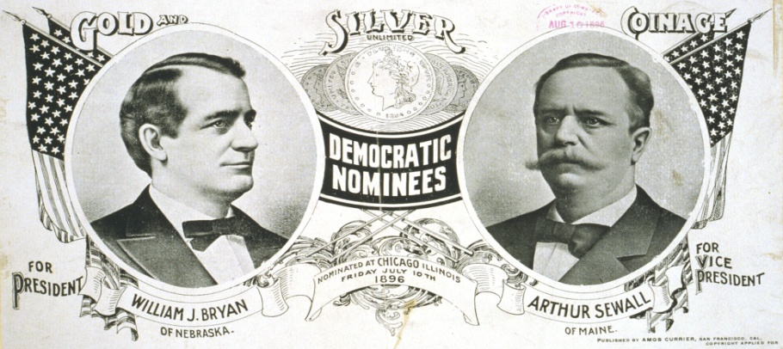
- Populism was a movement to increase whose political power? _____________________
- Farmers felt victimized by what two faraway entities? ____________________________
- By 1895 how much money was in circulation for each person? _____________________
- What did farmers call the decision to stop minting silver? _________________________
- Who founded the Patrons of Husbandry in 1867? ________________________________
- By 1874 the Grange had how many members? __________________________________
- Define cooperatives. ______________________________________________________
- What Supreme Court decision forbade regulation of railroads? _____________________
- What new organization began to form as the Grange fell apart? _____________________
- Alliance members in what state formed the People’s Party? ________________________
- Where did the People’s Party hold its first national convention? ____________________
- Whom did the People’s Party nominate for president in 1892? _____________________
- Define graduated income tax. _______________________________________________
- What issue did the People’s Party focus on in 1896? _____________________________
- Whom did the People’s Party support for president in 1896? _______________________
- How old was Bryan when he was nominated for president? ________________________
- Whom did the Republicans nominate for president in 1896? _______________________
- The Republicans promised that McKinley would provide what? ____________________
- What percent of the popular vote did McKinley capture? __________________________
Election of 1896 Chart (p. 246)

- What state had the largest number of electoral votes? _____________________________
- How many electoral votes did Iowa have? _____________________________________
- What state split its electoral votes? ___________________________________________
- How many more electoral votes did McKinley win than Bryan? ____________________
- Geographically, what two parts of the country went for Bryan? _____________________

Essay Questions
What were some of the problems farmers faced in the late nineteenth century? ________________________________________________________________________________________________________________________________________________________________________________________________________________________________________________________________________________________________________________________
What were some of the People’s Party proposals at its national convention in 1892? ________________________________________________________________________________________________________________________________________________________________________________________________________________________________________________________________________________________________________________________
Compare and contrast the political campaigns of McKinley and Bryan. __________________________________________________________________________________________________________________________________________________________________________________________________________________________________________
Extra Credit: Who was William McKinley’s vice-president from 1897 to 1899? Why didn’t he finish his term? ____________________________________________________________________________________________________________________________________________________________

