Name ____________________ Date ____________________ Period ____________________
U.S. History
Chapter 6.2
Urbanization (pp. 222-229)
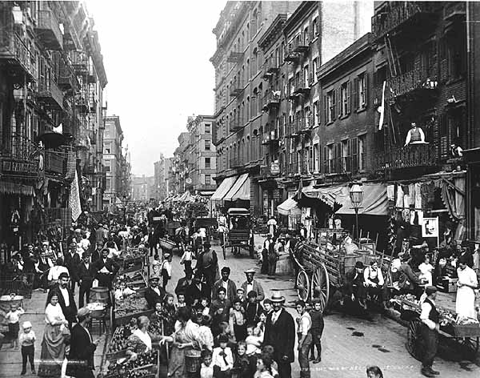
- By 1900 how many cities with over 2,500 people did the U.S. have? ________________
- What was the first skyscraper? ______________________________________________
- No one contributed more to the design of skyscrapers than whom? __________________
- What city first used cable cars for mass transit? _________________________________
- Who developed the first electric trolley car in 1887? _____________________________
- How much did Corenlius Vanderbilt’s grandson spend on his chateau? _______________
- Most middle-class families had how many servants? _____________________________
- In New York how many working class residents lived in tenements? ________________
- What was the average industrial worker’s annual income? _________________________
- What percent of working class families relied on more than one wage earner? _________
- What was the largest source of employment for women? __________________________
- What percent of old people lived with their grown children? _______________________
- From 1880 to 1900 the murder rate per million people jumped to: ___________________
- In How the Other Half Lives, Riis accused what of breeding poverty? ________________
- Define Political Machine. __________________________________________________
- Define Graft. ____________________________________________________________
- Who was one of New York City’s most powerful party bosses? ____________________
- What was New York City’s Democratic political machine called? __________________
- Who was Tammany Hall’s leader during the 1860s and 70s? _______________________
- What cartoonist blasted bosses for their corruption? ______________________________
Essay Questions
Why did immigrants settle in big cities? Why did rural Americans? _________________________________________________________________________________________________________________________________________________________________________________________________________________________________
What technologies were necessary in order to build modern skyscrapers? (See “Technology and History on page 223). _________________________________________________________________________________________________________________________________________________________________________________________________________________________________
What was the difference between graft and “honest” graft? Give examples. _________________________________________________________________________________________________________________________________________________________________________________________________________________________________
Extra Credit: Listed below, on the left, are the eight biggest cities (by population) in the United States in 1900. On the right, list the eight biggest cities in the U.S. in 2000.
1. | New York | 1.
2. | Chicago | 2.
3. | Philadelphia | 3.
4. | St. Louis | 4.
5. | Boston | 5.
6. | Baltimore | 6.
7. | Cleveland | 7.
8. | Buffalo | 8.

