Name ____________________ Date _____________________ Period ___________________
U.S. History
Chapter 6.1
Immigration (pp. 214-221)
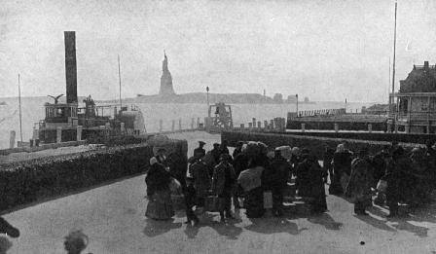�
- How many Europeans immigrated to the U.S. Between 1865 and 1914? ______________
- By the 1890s half of all immigrants came from where? ___________________________
- What percent of these new immigrants were men? _______________________________
- What were the cheapest accommodations on a steamship called? ___________________
- How long did the journey to the U.S. take? _____________________________________
- Passengers usually disembarked at what island in New York Harbor? ________________
- How long did it take most immigrants to pass through Ellis Island? _________________
- One out of how many newcomers was marked with an H, K, S, or X? _______________
- Who was Jacob Riis? ______________________________________________________
- What 1850 rebellion prompted many Chinese to leave for the U.S.? _________________
- Chinese immigrants to the U.S. mainly settled where? ____________________________
- Immigration from what country soared between 1900 and 1910? ___________________
- What barracks did California open for Asian immigrants in 1910? __________________
- Define Nativism. _________________________________________________________
- Who founded the American Protective Association? _____________________________
- Who suffered most from anti-Catholic feeling? _________________________________
- What anti-immigrant act did Congress pass in 1882? _____________________________
- In 1906 what city ordered Asian students into segregated schools? __________________
- What president negotiated the “Gentlemen’s Agreement?” ________________________
- Presidents Taft and Wilson both vetoed legislation to require what? _________________
Chart: Consulting the chart on page 217, answer the following questions.
- What state registered the highest immigration from China? ________________________
- Most immigrants to Massachusetts came from where? ____________________________
- How many Germans settled in Wisconsin? _____________________________________
- What state registered the highest immigration from Mexico? _______________________
- How many Polish immigrants settled in New York? ______________________________
Essay Questions
What were some of the reasons Europeans immigrated to the United States? ____________________________________________________________________________________________________________________________________________________________________________________________________________________________________________________________________________________________________________
Compare and contrast immigration procedures at Ellis Island and Angel Island. ____________________________________________________________________________________________________________________________________________________________________________________________________________________________________________________________________________________________________________
Why did nativists oppose immigration? ____________________________________________________________________________________________________________________________________________________________________________________________________________________________________________________________________________________________________________
Extra Credit: Ask an East High School staff member to identify the country or countries his or her ancestors came from.
Staff Person: ________________________________________________________________ Countries: __________________________________________________________________

