Name ____________________ Date ____________________ Period ____________________
U.S. History
Chapter 4.1
Miners and Ranchers (pp.158 – 163)

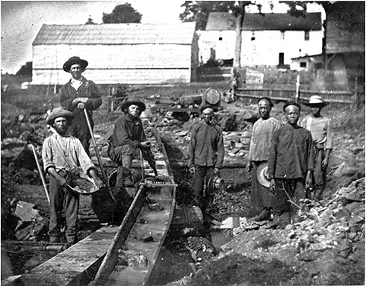
- _____________________ played an important role in the settling of the American West.
- After the Civil War the United States changed from a farming nation to a ____________
- News of the __________ __________, as the strike was called brought a flood of eager prospectors to Virginia City.
- Quickly growing towns were called __________________________________________
- Often “law and order” was enforced by _______________ ________________________
- _______________ were usually first to arrive at a mining site, but women soon followed.
- Boomtowns could not last forever because, ___________________________________
- Some towns could were completely abandoned, becoming ___________ ____________
- The Colorado Mountains contained gold and silver, but much was hidden beneath the surface and hard to _______________________________________________________
- In 1889 Congress admitted three new states: ____________ ___________ ___________
- Tombstone became famous for its ___________________________________________
- Extracting minerals from rugged mountains required ____________ and ____________
- While many Americans headed to the Rocky Mountains to mine gold and silver, others began ____________________ _____________________ on the Great Plains.
- The ______________________________________ was descended from Spanish cattle.
- Cattle ranching also prospered on the plains because of the ___________ ____________
- After the ____________________ ___________________________ beef prices soared.
- Stray calves without brands were called _______________________________________
- Cowboys drove the cattle north from Texas to Kansas and points beyond.
- For cowboys _____________ ___________ ended the adventure of the long cattle drive.
- For centuries, much of what is today the American Southwest belonged to ____________
- In California, the Spanish mission system had collapsed by the early ________________
- Landowners owned vast _______________________________________- huge ranches.
- As they had done with Native Americans, settlers clashed with Mexican Americans over __________________.
- Hispanics settled in neighborhoods called______________________________________

Explain each of the following methods:
- Placer mining- ________________________________________________________________________________________________________________________________________________________________________________________________________________________________________________________________________________________________________________________________________________________________________
- Sluice Mining- ________________________________________________________________________________________________________________________________________________________________________________________________________________________________________________________________________________________________________________________________________________________________________
- Hydraulic Mining- ________________________________________________________________________________________________________________________________________________________________________________________________________________________________________________________________________________________________________________________________________________________________________
- Quartz Mining- ________________________________________________________________________________________________________________________________________________________________________________________________________________________________________________________________________________________________________________________________________________________________________

