Name ____________________ Date ___________________ Period ____________________
U.S. History
Chapter 18.2
Challenging Segregation (pp.630-639)
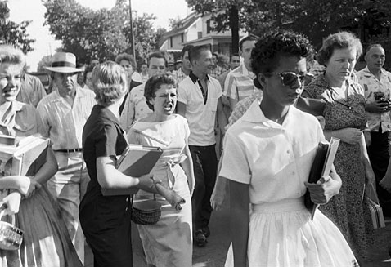
- In 1959, four students staged a sit-in at what store in Greensboro? __________________
- In 1960, Ella Baker helped student leaders from what group? ______________________
- The idea for the Voter Education Project came from whom? _______________________
- In what Alabama city were Freedom Riders viciously beaten? ______________________
- Who was the head of the police in that city? ____________________________________
- Whom did President Kennedy appoint for a federal judgeship? _____________________
- Who tried to help African Americans register to vote by having the civil rights division of the Justice Department file lawsuits across the South? ________________________________________________________________________
- In 1962, who attempted to register at the University of Mississippi? _________________
- What Mississippi governor blocked his path? ___________________________________
- In 1963, King decided to launch demonstrations in what city? ______________________
- What is one of the most eloquent defenses of nonviolent protest ever written? ________________________________________________________________________
- What governor tried to block two African Americans from enrolling at the University of Alabama? ________________________________________________________________________
- How many demonstrators of all races flocked to the nation’s capital? ________________
- How many days did Southern senators filibuster the Civil Rights Act? _______________
- On what date did President Johnson sign the Civil Rights Act? _____________________
- What amendment eliminated poll taxes in federal elections? _______________________
- How many African American churches in Mississippi were destroyed between June and October 1964? ________________________________________________________________________
- What city did King select as a focal point for the campaign for voting rights? ________________________________________________________________________
- What prize did King receive in 1964? _________________________________________
- At what bridge was the “March of Freedom” halted? _____________________________
- The Passage of what act marked a turning point in the civil rights movement? ________________________________________________________________________

Essay Questions
Once in office, President Kennedy disappointed many African Americans. Why was he “as cautious as Eisenhower on civil rights?” (See p. 633)
________________________________________________________________________________________________________________________________________________________________________________________________________________________________________________________________________________________________________________________
What action to end segregation did President Kennedy take after he returned from his meeting with Khruschev? What action did Robert Kennedy take? (See p. 634)
________________________________________________________________________________________________________________________________________________________________________________________________________________________________________________________________________________________________________________________
Extra Credit: What song did Bob Dylan perform at the March on Washington for Jobs and Freedom in 1963?
______________________________________________________________________________

