Name ____________________ Date _____________________ Period ___________________
U.S. History
Chapter 18.1
The Movement Begins (pp.622-629)
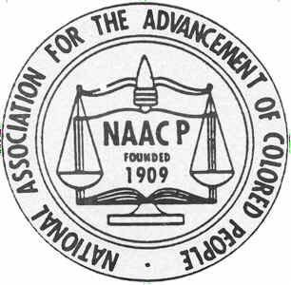
- Who refused to give up her seat on a Montgomery, Alabama, bus? __________________
- Plessy v. Ferguson had established what doctrine? _______________________________
- Laws segregating African Americans were nicknamed what? ______________________
- During the Great Migration, many African Americans moved where? ________________
- What form of protest did CORE begin using? ___________________________________
- What did the Supreme Court rule in Brown v. Board of Education of Topeka? _________
- What did Senator Byrd call on Southerners to adopt? _____________________________
- How many Southern members of Congress signed the Southern Manifesto? ___________
- Who was the leader of the Montgomery Improvement Association? _________________
- King believed that the only way to end segregation and racism was through what? ________________________________________________________________________
- King drew upon whose philosophy and techniques? ______________________________
- In 1957, African Americans ministers led by King established what? ________________
- Eisenhower was the first president since reconstruction to do what? ________________________________________________________________________
- What governor opposed the desegregation of Little Rock High? ____________________
- What elite army division was sent to Little Rock? _______________________________
- The Civil Rights Act of 1957 was intended to protect what? _______________________
Matching: Match the following people with the correct description.
17. |  | Linda Brown | - Co-founded CORE
18. |  | James Farmer | - Led Montgomery bus boycott
19. |  | Martin Luther King, Jr. | - NAACP’s brilliant chief counsel
20. |  | Thurgood Marshall | - Refused to give up her seat on a bus
21. |  | Rosa Parks | - Denied admission to a neighborhood school

True or False
22. | Jim Crow facilities were of equal quality to those provided whites | T or F
23. | During the 1930s, many blacks benefited from the New Deal | T or F
24. | One of CORE’s favorite tactics was the sit in | T or F
25. | The Supreme Court’s decision in Brown v. Board of Education was unanimous | T or F
26. | After Brown v. Board of Education, all schools in the South were immediately desegregated | T or F
27. | The Montgomery bus boycott was a dramatic success | T or F
28. | President Eisenhower sympathized with the civil rights movement and personally disagreed with segregation | T or F

Essay Question: Considering that President Eisenhower sympathized with the civil rights movement, why was he opposed to strong action to end segregation?
________________________________________________________________________________________________________________________________________________________________________________________________________________________________________________________________________________________________________________________________________________________________________________________________________________________________________________________________________________________________________________________________________________________________________________________________________________________
Extra Credit: How many days did the Montgomery bus Boycott last? __________________

