Name ____________________ Date ____________________ Period ____________________
U.S. History
Chapter 17.2
JFK and the Cold War (pp.602-607)
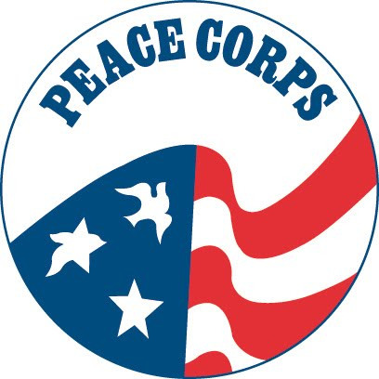
- What was exploding throughout the developing world? ___________________________
- Kennedy felt Eisenhower had relied too heavily on what? _________________________
- Kennedy wanted to renew diplomatic focus on what region? _______________________
- How much did the U.S. pledge to help Latin American countries? __________________
- What program sent Americans to provide humanitarian services in less developed countries? _______________________________________________________________
- Who was the first person to orbit the Earth? ____________________________________
- Who was the first American to orbit the Earth? _________________________________
- On what date did Armstrong and Aldrin land on the moon? ________________________
- Who overthrew the corrupt Cuban government in 1959? __________________________
- At what place did 1,400 armed Cuban exiles land on April 17, 1961? ________________
- Where did Kennedy meet Khrushchev in June 1961? _____________________________
- For nearly 30 years, what stood as a symbol of Cold War divisions? _________________
- When did Kennedy announce that the Soviet Union had placed missiles in Cuba? ______
- What did Kennedy order to stop the delivery of more missiles? _____________________
- In August 1963, the two countries (U.S. and Soviet Union) agreed to a treaty that banned what? __________________________________________________________________
- When was Kennedy assassinated? ____________________________________________
- What commission investigated the assassination? ________________________________
- Who succeeded Kennedy as President? ________________________________________
Matching
19. |  | Neil Armstrong | - Ruler of Cuba
20. |  | Fidel Castro | - Ruler of the Soviet Union
21. |  | Nikita Khrushchev | - First man to walk on the moon
22. |  | Lee Harvey Oswald | - Man who shot Lee Harvey Oswald
23. |  | Jack Ruby | - Assassin of President John Kennedy

True or False
24. | Kennedy took office at a time of global stability and good relations between the US and the Soviet Union | T or F
25. | The bay of Pigs invasion was a great success for the US | T or F
26. | The first person to orbit the Earth was an American | T or F
27. | Kennedy ordered a wall built around West Berlin | T or F
28. | In exchange for the removal of Soviet missiles from Cuba, Kennedy promised not to invade Cuba | T or F

Map Exercise: Consulting the map on p. 606, answer the following questions
29. The Soviet missiles were placed by what Cuban city? _________________________
30. Approximately how many miles were the missiles from Miami? _________________
31. What sea lies to the South of Cuba? _______________________________________
32. What does the blue line around Cuba signify? _______________________________
33. Name two islands around Cuba? __________________________________________

Essay Question: Why was the Cuban Missile Crisis “by far the most terrifying crisis of the Kennedy era?” ________________________________________________________________________________________________________________________________________________________________________________________________________________________________________________________________________________________________

Extra Credit: From what building did Oswald fire the shots that killed Kennedy? ________________________________________________________________________

