Name ____________________ Date ____________________ Period ____________________
U.S. History
Chapter 17.1
The New Frontier (pp.596-601)
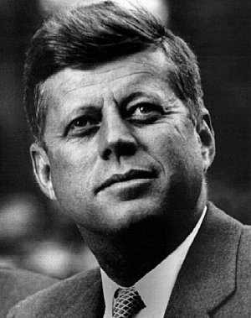
- When was the first televised presidential debate? ________________________________
- Who called the presidential candidates “Processed Politicians?” ____________________
- What was John Kennedy’s religion? __________________________________________
- What two issues did the campaign center on? ___________________________________
- Both candidates portrayed themselves as what? _________________________________
- Kennedy expressed concern about a suspected what? _____________________________
- Kennedy won the election by how many popular votes? __________________________
- What did Kennedy call his legislative agenda? __________________________________
- To increase economic growth and create more jobs, what did Kennedy advocate? ______
- What industry angered Kennedy by raising prices sharply? ________________________
- Who began a day camp for children with disabilities? ____________________________
- What was first held in Chicago in 1968? _______________________________________
- The Warren Court required states to reapportion electoral districts according to what principle? _______________________________________________________________
- Define “due process.” _____________________________________________________
- In cases such as Engel v. Vitale and Abington School District v. Schempp, the Court reaffirmed the separation of what? ________________________________________________________________________
Map Reading: Consulting the map on p. 597, answer the following questions.

- How many electoral votes did Kennedy win? ___________________________________
- What two states split their electoral votes? _____________________________________
- To which candidate did Mississippi award its electoral votes? ______________________
- What one state in the Far West voted for Kennedy? ______________________________
- How many electoral votes did Iowa have in 1960? _______________________________

Essay Questions
In his Inaugural Address, President Kennedy said, “My fellow Americans, ask not what your country can do for you – ask what you can do for your country.” What do you think he meant by this? ____________________________________________________________________________________________________________________________________________________________________________________________________________________________________________________________________________________________________________________________________________________________________________________________________________________________________________________________________________________
What did the U.S. Supreme Court rule in Miranda v. Arizona? Do you agree with this decision? Why or why not? ______________________________________________________________________________________________________________________________________________________________________________________________________________________________________________________________________________________________________________________________________________________________________________________________________
Extra Credit: John F. Kennedy was the second youngest elected president in U.S. History. Who was the first? ______________________________________________________________________________

