Name ____________________ Date ____________________ Period ____________________
U.S. History
Chapter 16.1
Truman and Eisenhower (p.566-571)
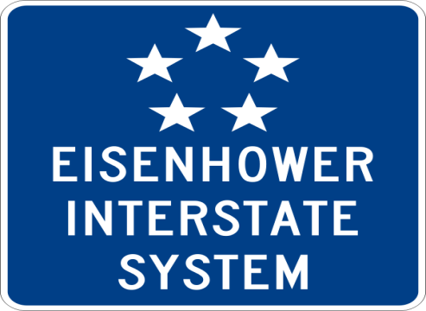
- What was the Servicemen’s Readjustment Act popularly called? ____________________
- Following the end of the war, what triggered labor unrest? ________________________
- Name 3 industries where workers went on strike? _______________________________
- What did the Taft-Hartley Act outlaw? ________________________________________
- What did labor leaders call Taft-Hartley? ______________________________________
- Truman issued an executive order ending segregation where? ______________________
- Who was the Dixiecrat candidate for President in 1948? __________________________
- Who was the Progressive candidate for President in 1948? ________________________
- Who was the Republican candidate for President in 1948? _________________________
- What did Truman call the Republican majority Congress? _________________________
- What did Truman call his domestic program? ___________________________________
- The 81st Congress raised the minimum wage to what amount per hour? ______________
- What effectively ended Truman’s fair deal? ____________________________________
- Whom did the Democrats nominate for President in 1952? ________________________
- What slogan did the Republicans adopt in 1952? ________________________________
- How many electoral votes did Eisenhower receive? ______________________________
- How did Eisenhower describe his political beliefs? ______________________________
- What was the largest public works project in American history? ____________________
- The St. Lawrence Seaway connected the Great Lakes with what? ___________________
- By 1956 the nation had shifted back to what kind of economy? _____________________
Definitions: Use the glossary in the back of the book to define the following terms.
- Closed shop ________________________________________________________________________________________________________________________________________________
- Dynamic conservatism ________________________________________________________________________________________________________________________________________________
- Right to work law ________________________________________________________________________________________________________________________________________________
- Union shop ________________________________________________________________________________________________________________________________________________
Matching: Match the following presidential candidates with the correct description.
25. |  | Thomas Dewey | - Republican candidate in 1948
26. |  | Dwight Eisenhower | - Democratic candidate in 1948
27. |  | Strom Thurmond | - States’ Rights candidate in 1948
28. |  | Harry Truman | - Progressive candidate in 1948
29. |  | Henry Wallace | - Republican candidate in 1952

Essay Question
What parts of Truman’s Fair Deal program were passed by Congress? Which were not?
________________________________________________________________________________________________________________________________________________________________________________________________________________________________________________________________________________________________
Extra Credit
Why does the Interstate System sign at the top of this worksheet have 5 stars on it? ________________________________________________________________________

