Name ____________________ Date ____________________ Period ____________________
U.S. History
Chapter 15.3
The Cold War and American Society (p.546-553)
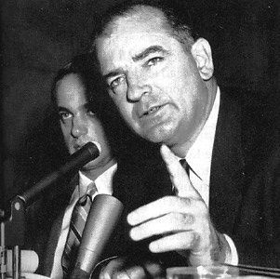
- When did the Red Scare begin? ______________________________________________
- Define subversion. ________________________________________________________
- Between 1947 and 51, how many federal employees were screened for loyalty? _______
- What did HUAC stand for? _________________________________________________
- One of HUAC’s first hearings focused on what industry? _________________________
- Who was head of the Screen Actors Guild? ____________________________________
- Whom did Whittaker Chambers identify as a Communist spy? _____________________
- The Rosenbergs were condemned to death for what? _____________________________
- What did Project Verona crack? _____________________________________________
- What act required union leaders to take loyalty oaths? ____________________________
- What two events in 1949 seemed to prove the U.S. was losing the Cold War?
- _____________________________________________________________________
- _____________________________________________________________________
- Joseph R. McCarthy was a senator from what state? ______________________________
- What law required American Communists to register? ____________________________
- What was “McCarthyism?” _________________________________________________
- In 1954 McCarthy began to look for Soviet spies where? __________________________
- What weekly show kept television viewers on edge? _____________________________
Scrambled Names: Unscramble the following names.
- RHEOVO (Director of the FBI) _____________________________________________
- XINNO (Representative from California who pursued Hiss) _______________________
- CLEHW (Army lawyer in Army-McCarthy hearings) ____________________________
- SHYERE (Author of Hiroshima) _____________________________________________
- CATYHMRC (anti-Communist “witch hunter”) _________________________________

Matching: Match the following terms with their definitions
22. |  | Blacklist | - An agreement not to hire certain persons
23. |  | Censure | - An effort to weaken society secretly
24. |  | Fallout | - Lying under oath
25. |  | Perjury | - A declaration of formal disapproval
26. |  | subversion | - The radiation after a nuclear blast

Essay Questions
What tactics did Senator McCarty used to discredit witnesses? ______________________________________________________________________________________________________________________________________________________________________________________________________________________________________________________________________________________________________________________________________________________________________________________________________
How did schools prepare for a surprise Soviet attack? Why were their preparations inadequate? ________________________________________________________________________________________________________________________________________________________________________________________________________________________________________________________________________________________________________________________
Extra Credit: Who starred as Herb Philbrick in the television series I Led Three Lives? ______________________________________________________________________________

