Name ____________________ Date _____________________ Period ___________________
U.S. History
Chapter 14.3
Life on the Home Front (p.500-507)
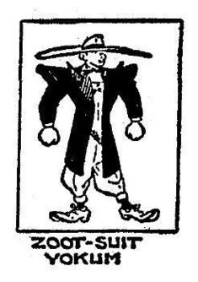
- Mobilizing the economy created how many new jobs? ____________________________
- What character from a popular song became a wartime symbol? ____________________
- By the end of the war, how many women were working? __________________________
- Who was head of the Brotherhood of Sleeping Car Porters? _______________________
- What executive order outlawed racial discrimination in hiring? _____________________
- Under the Bracero Program, how many Mexicans came to the U.S.? _________________
- How many Americans moved during the war? __________________________________
- How much did a “hot bed” cost? _____________________________________________
- What Act provided $150 million for housing? __________________________________
- Where did the worst racial violence of the war erupt? ____________________________
- What new style of suit angered many Americans? _______________________________
- How many Hispanic Americans served in the armed forces? _______________________
- How many internment camps were set up for Japanese Americans? _________________
- The OPA and OES worked to control what? ____________________________________
- During the war, what was the speed limit for cars? _______________________________
- Ration coupons of what color were needed to buy meat? __________________________
- What were backyard gardens called during the war? _____________________________
- Individuals bought how much worth of war bonds? ______________________________
Fill in the Blank
- This outfit, worn by Mexican American teenagers, featured very baggy, pleated pants and an overstuffed, knee-length jacket with wide lapels. ________________________________________________________________________
- This fictional character from a popular song by the Four Vagabonds became a symbol of the campaign to hire women for war work? ________________________________________________________________________
- This executive order issued by President Roosevelt on June 25th, 1941, declared that “there shall be no discrimination in the employment of workers in defense industries or government because of race, creed, color, or national origin.” ________________________________________________________________________
- This new industrial region was created by the growth of Southern California and the expansion of cities in the Deep South? ________________________________________________________________________
- This park in Detroit Michigan, was the scene of a racial confrontation that spread throughout the city and claimed 34 lives before the violence ended? ________________________________________________________________________
Essay Question: What happened to Japanese Americans during the war? How did the U.S. justify its treatment of Japanese Americans? _____________________________________________________________________________________________________________________________________________________________________________________________________________________________________________________________________________________________________________________________________________________________________________________________________________________________________________________________________________________________________________________________________________
Extra Credit: What was the name of the female worker at the Willow Run Aircraft Factory who was the model for “Rosie the Riveter?” ___________________________________________________________________________

